

**Mansoura University**

**Faculty of Computers and Information**

**Computer Science Department**

**SCRIPTOMOVIE**

**Intelligent system to convert script to animation movie**

*Pre-master project*

**Department of Computer Science,**

**Faculty of Computers and Information**

**Mansoura University**

*By*

**Mohamed Hossam Elashry**

*Supervised by*

**Prof. Magdy Zakaria**

**Department of Computer Science**

**Faculty of Computers and Information**

**Mansoura University**

**Dr. Reem Eldeeb**

**Department of Computer Science**

**Faculty of Computers and Information**

**Mansoura University**

**2019/2020**

# *Contents*

# Acknowledgements 3 Dedication 4 Abstract 5 Chapter 1 6 Chapter 2 19 Chapter 3 30

# References 33

***Acknowledgements***

First and foremost, we would like to thank the chairman of our faculty.  
we would also like to express our gratitude and appreciation to:  
 Prof. Magdy Zakaria

Dr. reem

for all the help and guidance, they provided throughout our education.

This project could not be done without them, who not only served as our supervisor but also encouraged us.   
so, we thank them and also, we thank the entire staff of the department.

# *dedication*

# We proudly dedicate this project and our efforts to our families, friends and our supervisor who made this accomplishment possible.

# 

# 

# *Abstract:*

# We decided to simulate some events in text script in some animated videos help people to more understand the context meaning of the script first we map the text to sentences clearer and more detailed then we use this sentence to describe the images or frames to build.

The main goal now is to use the AI technologies to create  an intelligent system we able to feed its Perception as an intelligent machine, the knowledge of the story, the scenario of events, the arrangement of events then train the machine using some CV technologies to generate the image of each event as a frame of our animated video, certain number of frames per second lead to an illusion of continuous motion.

this document describes my Pre master project in 3 chapters:

chapter one includes an **introduction** to the project.  
chapter two includes previous **work**.   
chapter three includes **CONCLUSION AND FUTURE WORK**.

# Chapter 1:

INTRODUCTION

**This chapter includes:**

1. **Introduction to the field of our project.**
2. **Introduction to the problem.**
3. **Customers and their needs.**

**Section 1: Introduction to the field of our project**

This project uses many techniques to reach the desired results. The most important part of the project is the understanding of natural languages ​​as well as the computer vision to simulate the movement of characters.   
  
 **animation**Is an imitation of real-life motion through moving pictures. Still pictures when made to move at certain number of frames per second lead to an illusion of continuous motion.

The animation effect is essentially accomplished by making images move over sequentially in quick succession. The difference between two consecutive images is so minimal that human eye fails to understand the same during transition. Phi phenomena and beta movement are thought to give rise to an illusion which brings motion graphics to life. The actual reason for illusory movement is yet to be ascertained.

Animations were earlier broadcasted in analogue mode through TV and video players. Now, the electronic devices play out animation in digital mode. To facilitate display of animation on computers, Flash and Gif techniques were initially used.

For most people, animation is just for entertainment as they do not understand different needs of animation in today’s world. However, if you look at the uses of animation in a slew of areas, the possibilities are limitless. It can even be considered as a unique branch of technology which can bring matchless value to a trove of business and entertainment activities.

# Natural language understanding (NLU)

Is a branch of artificial intelligence (AI) that uses computer software to understand input made in the form of sentences in text or speech format ,NLU directly enables human-computer interaction (HCI), NLU understanding of natural human languages enables computers to understand commands without the formalized syntax of computer languages and for computers to communicate back to humans in their own languages , The field of NLU is an important and challenging subset of natural language processing (NLP). While both understand human language, NLU is tasked with communicating with untrained individuals and understanding their intent, meaning that NLU goes beyond understanding words and interprets meaning. NLU is even programmed with the ability to understand meaning in spite of common human errors like mispronunciations or transposed letters or words, NLU uses algorithms to reduce human speech into a structured ontology. AI fishes out such things as intent, timing, locations and sentiments.

For example, a request for an island camping trip on Vancouver Island on the 18th of august might break down something like this: Ferry tickets [intent] / need: camping lot reservation [intent] / Vancouver Island [location] / August 18th [date].

**Computer vision** Is an interdisciplinary scientific field that deals with how computers can gain high-level understanding from digital images or videos. From the perspective of engineering, it seeks to understand and automate tasks that the human visual system can do.

Computer vision tasks include methods for acquiring, processing, analyzing and understanding digital images, and extraction of high-dimensional data from the real world in order to produce numerical or symbolic information, e.g. in the forms of decisions. Understanding in this context means the transformation of visual images (the input of the retina) into descriptions of the world that make sense to thought processes and can elicit appropriate action. This image understanding can be seen as the disentangling of symbolic information from image data using models constructed with the aid of geometry, physics, statistics, and learning theory.

The scientific discipline of computer vision is concerned with the theory behind artificial systems that extract information from images. The image data can take many forms, such as video sequences, views from multiple cameras, multi-dimensional data from a 3D scanner or medical scanning device. The technological discipline of computer vision seeks to apply its theories and models to the construction of computer vision systems.

**Section 2: Description of the problem**

In our project, we seek to have a software convert any short story to professional animation video.

From a view of **NLU** we need to define a semantic base for knowledge representation, in NLP Syntactic Parsing or Dependency Parsing is the task of recognizing a sentence and assigning a syntactic structure to it. The most widely used syntactic structure is the parse tree which can be generated using some parsing algorithms. These parse trees are useful in various applications like grammar checking or more importantly it plays a critical role in the semantic analysis stage. For example, “*John hit Mary by throwing a stick at her.*” we need to figure out its subject, objects, and attributes to help us figure out the parse tree of Syntactic parsing but still not Making sense of some inputs and no Perception / Understanding.

Understanding is like parsing, Understanding has a strong top down component. It involves concept driven mapping into preconceived notions, rather than data driven bottom up approach.

From a view of **CV**, it takes way too long to create animation videos. For example, Walt Disney took 9 years to make his first animated film on paper. Disney can push out a full-length CGI film in 3 years now. Studio Ghibli took 7 years to make it spirited away. Vivziepop made a 2minute hand drawn animated music video in 6 months in TV paint. The guys at family Guy can composite a 20minute episode in 3 weeks. Alan Becker made a 5minute stick figure animation which took 3 months in Adobe flash.

This could range from a few hours to several days or months depending on the subject matter and complexity of the animation. An animated Explainer video that uses simple cut-out style animated characters, and very limited movement such as a hand wave or shake, and a simple walk cycle can be completed with pre designed puppets in vector animation software (using narration - no lip sync) in a day. However. This style of animation is better known and described as Motion Graphics and not actual animation.

A complex fight scene or other detailed scenario (crowd running, castle siege, etc) involving multiple characters, you could be looking at a couple days, if not weeks or months, depending once again on the design and style of the characters and overall animation. (Vector) - Digital is faster than Frame by Frame (Hand Drawn), 3D is slower than 2.5D Paralax (Motion Comic Style).

Some studios can produce 2 minutes of animation in a much shorter time frame. The guys down at South Park produce a full 22minute episode in six days, from concept to writing, voice acting, storyboards, animatic, animating, editing and final cut. Six days. That is unbelievably fast. But they are a large team of very skilled individuals. This is also not common practice. Most animation studios produce a 22minute animated cartoon episode in 10 months, with the use of in-house animators and artists, and a second team overseas in places like Korea or India to complete the bulk of the work. It is more cost effective and they have larger teams which help.

Our project aims to reduce the time used to create animation by providing a neural network model that can take a clear understanding of text to generate an image and simulate the action once we have a set of images, we can create an animation video in a very short time.

Another problem is the entertainment and fun. Cartoons are the most popular entertainment for children. Children have grown much more interested in cartoons in recent years and it has become the main pastime for them. Mostly children begin watching cartoons and animated movies at the early age of six months, and by the age of two or three children become enthusiastic viewers.

In fact, watching animated videos can be a good thing: preschoolers can get help learning the alphabet, school kids can learn about wildlife on nature shows. No doubt about it, animation can be an excellent educator and entertainer.

**Section 3: Customers and their needs**

Our project focuses the most on animation movie makers and children. However, anyone who is interested can use it but those are the most important customers.

For Children, it will be fun and educational at the same time since the animation has the ability to deliver the information much faster and informative rather than static text.

For animation video makers, it will reduce the time needs for creating animation video. It will save time, providing a new type of production, Conceptual meaning and making a more creative story.

However, let us find out some of the most important areas where animation is extensively used.

1. [**Education**](https://mapsystemsindia.com/resources/animation-in-education.html)Everybody understands that humans have a tendency to remember videos and images more than textual content. So, it is natural that animation for educational purposes can be effectively utilized to enhance the reception levels of the students and trainees. As animated videos can effectively improve the quality of reception of the learners, it brings about exceptional changes to the academic capabilities of people without any doubt. Graphics is already used by several education portals and platforms where even the most complex and difficult concepts are shared to the students with greater reception.
2. **Entertainment**  
   There is no doubt there are various uses of animation multimedia and entertainment and perhaps it is extensively used for entertainment and perhaps it is the greatest use for computer graphics, as we know it. Diverse animation services are offered by several top animation companies to be used for entertainment in a range of platforms such as TV, internet and even on the phones. There are several animation series and movies created for children and adult audience that can be enjoyed as normal live-action movies. Famous animation programs such as Tom and Jerry, Mickey Mouse and Donald Duck are created to make everyone laugh all the while sharing important life lessons and moral values. Apart from such series, even a range of movies is created targeted at a wider audience that includes children and adults. Studios like Pixar, DreamWorks and DC Animation Studios are primarily involved with making animated movies.
3. **Advertisement**  
   If you consider the [benefits of animation in advertising](https://blog.mapsystemsindia.com/graphics/benefits-of-animation-in-advertising/), they are quite astounding. Advertisements are always about creative visualization and hence, it plays an important role in making effective commercials that can capture the imagination of the audience luring them to buy the product being advertised. Apart from using this for creating advertisements on TV, the advent of internet has also led to the creation of a new platform where animated advertisements can be used in search and display advertisements. If you consider advertisements without animation, large portion of the advertisements will be rendered uninspiring and boring.
4. [**Marketing**](https://mapsystemsindia.com/resources/animation-in-marketing.html)Animation brings lots of creativity to your marketing, which helps you to reach more demographics. An animated 3d demonstration of your product’s benefits instantly and it may be a more effective conversion.
5. **In Scientific Visualization**  
   It is extensively used to create accurate and representative scientific visualization for the purpose of research and analytical studies. It can be effectively used to represent and [create 3D models](https://mapsystemsindia.com/3d-services/3d-modeling-services.html) for a wide range of objects for realistic visualizations. An example could be in medical diagnosis where parts of body can be effectively studied and problems can be diagnosed more efficiently.
6. **Creative Arts**  
   Motion graphics is extensively used to demonstrate and generate the skills required to attend a certain level of creative proficiency. For example, an IT course designed for creative arts. Such courses will utilize animation to get the education across the class leveraging various presentations and diagrams created by means of animation.
7. **Gaming**  
   It would be an impossible task to find an industry where animation is as extensively used as in the gaming industry. It is an industry where everything is dependent on animation as most 3D characters for games are created with animation. It is the very basic upon which everything on a game is modeled and created. Also read our article about [3d character modeling practices for gaming](https://mapsystemsindia.com/resources/3d-modeling-practices-that-works-for-games-and-films.html) industry. All such activities as texturing, lighting and rigging are done by several graphic professionals as per the requirements of the clients
8. **Simulations**  
   Simulations are utilized in areas where real life training of people is dangerous or cannot be controlled. Military training exercises is one of the most adequate examples for this type of application of animation. Simulations are also used to train pilots without having to invest heavily on machines and fuel and without causing any damage to the trainees in case of any mishaps. Simulations are also used by various organizations to predict the outcome of a range of activities.
9. **Medical**  
   Animation is widely used in the medical industry these days. This allows professionals and medical students to visualize the details of the human anatomy with clarity. The use of animation in medical field is increasing over the years. You can view details of the human anatomy through [medical animation](https://mapsystemsindia.com/animation-services/medical-animation.html), even the ones that the naked eyes cannot see. As a result, surgeons are able to explore the replicas of human body, before conducting surgeries. New interns can get effective training on complex techniques of surgery. 3D animation can visually convey the intended message. Hospitals and other healthcare institutions have realized the benefits of 3d medical animation, and are pairing up with reputed platforms providing [animation services](https://mapsystemsindia.com/animation-services.html).
10. **Retail**  
    The retail industry has immensely benefitted from animated videos. The marketers use animations to showcase product attributes to their customers. 3D modeling and animation can interpret the functions of a product, along with its features in a lucid manner. Evidently, the importance of animated videos in the retail industry is rising. Well, certain products are difficult to be photographed. These products may have microscopic features, or you may have to display the object from multiple angles. In these cases, 3D animations come beneficial in demonstrating these product features.
11. **Architecture and Engineering**3D animation has greatly shaped the marketing mechanism of the real estate and engineering industry. In architecture, it is necessary to explain the proposed designs to potential customers in a simplified manner. The [importance of 3d animation in architecture](https://mapsystemsindia.com/resources/3d-animation-for-architecture-importance.html) lies in the fact, that these can be produced in quick time and reasonable costs. Besides, they simplify the interpretation process of the structure of the buildings. The construction firms can integrate every detail of the proposed plans in these animations. Designers are aware of the versatile application of animation and integrate these while designing the interiors.
12. **Manufacturing**  
    Animations and computer models are used to develop virtual models of various products in the manufacturing sector. These mechanical designs come handy to the business firms, as they can save a good amount of money in developing the products. Besides, they can detect problems in the models and eliminate the same, before developing the actual product. The uses of animation in different fields are increasing. Technological developments are expected to make these animations more sophisticated and effective.

These are some of the most widely acknowledged areas where animation is already utilized. However, it has many applications in other areas too. As the technology evolves and advances with some of the best animation software programs on the way, the demand for professional animation service providers has also boosted. It resulted in the increasing need for varied animated content with the use of 2D and 3D animations. Most of the times, it is [3D animation](https://mapsystemsindia.com/3d-services/3d-animation-services.html) which gets the credit for the creation of outstanding projects. Yet [2D animation](https://mapsystemsindia.com/digital-graphics-services/2d-animation-services.html) still holds its importance for crafting projects even if not implemented extensively. So, individuals get a wide range of options for availing these services at their convenience.

# Chapter 2:

PREVIOUS WORK

**This chapter includes:**

1. **Canva.**
2. **Storyboard pro.**
3. **Storyboard That.**
4. **WordsEye.**
5. **MovieStorm.**
6. **ScriptOmovie.**

**Section 1: Canva**

Build a brilliant storyboard in 5 simple steps

1. Create a new Canva account to get started with your own storyboard designs.
2. Choose from Canva library of professionally created templates.
3. Upload your own photos or choose from over 1 million stock images.
4. Fix your images, add stunning filters and edit text.
5. Save and share.

Disadvantages:

It is online and need an internet connection.

It uses 2D images not 3D models.

No physical animation, only sequence of images.

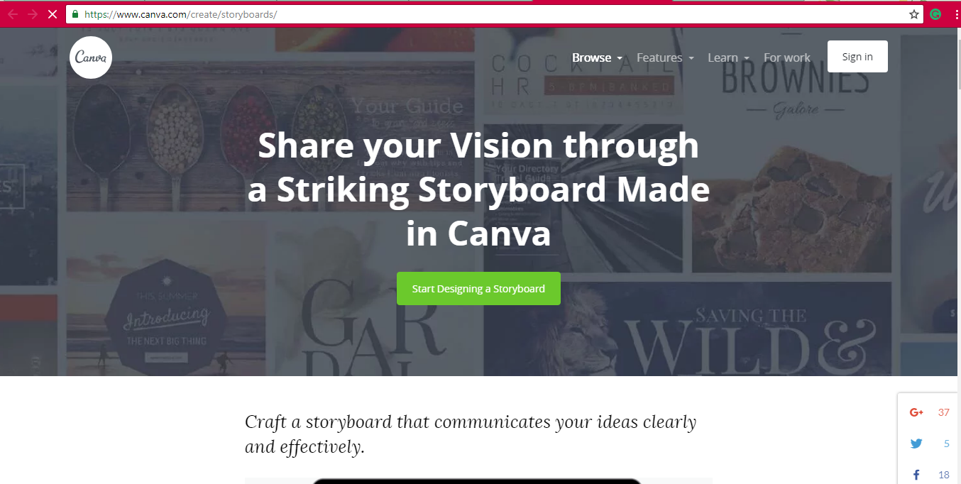

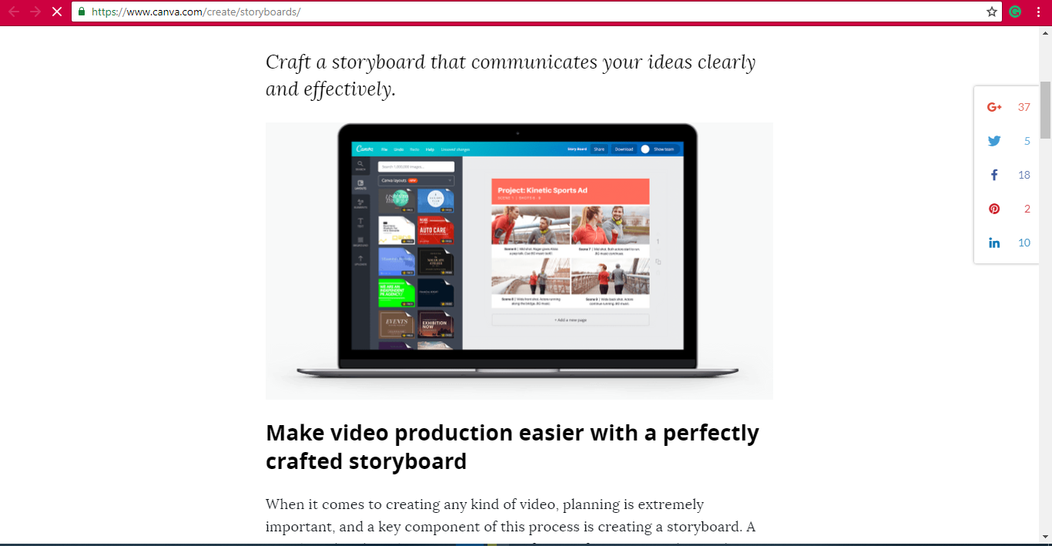

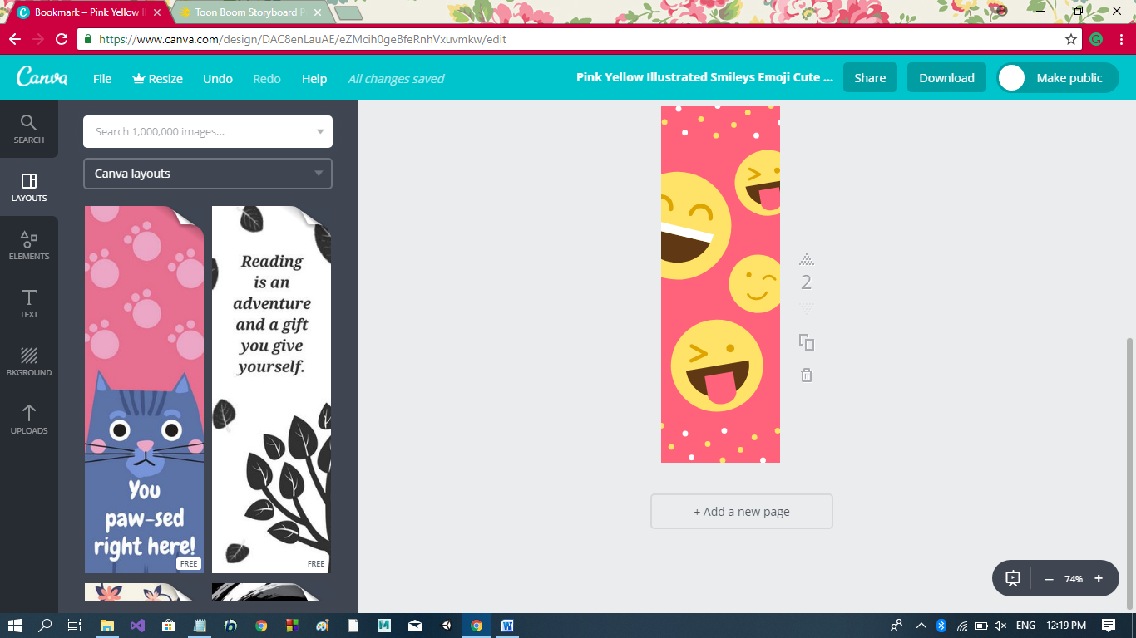

**Section 2: Storyboard Pro**

Storyboard Pro gives you everything you need to storyboard your episodic, advertising, film, explainer videos and other creative projects.

**Story Flow:** Go from script to storyboard in one seamless framework that allows you to visually organize the story as it unfolds

**Drawing & Sketching Tools:** Draw in any style using bitmap and vector drawing tools with access to multiple brushes and textures.

**Built-in Camera:** Create movement with the built-in 3D camera with thru-the-lens view

**Add 3D:** Import 3D models from FBX, Alembic, Collada, OBJ, 3DS. Mix 2D and 3D in a 3D space where assets interact the way you expect

**Animatic:** Time your panels. Add motion per layer and create impressive camera moves across panels

**Pipeline Integration:** Import scripts from Final Draft and standard image, vector and audio formats. 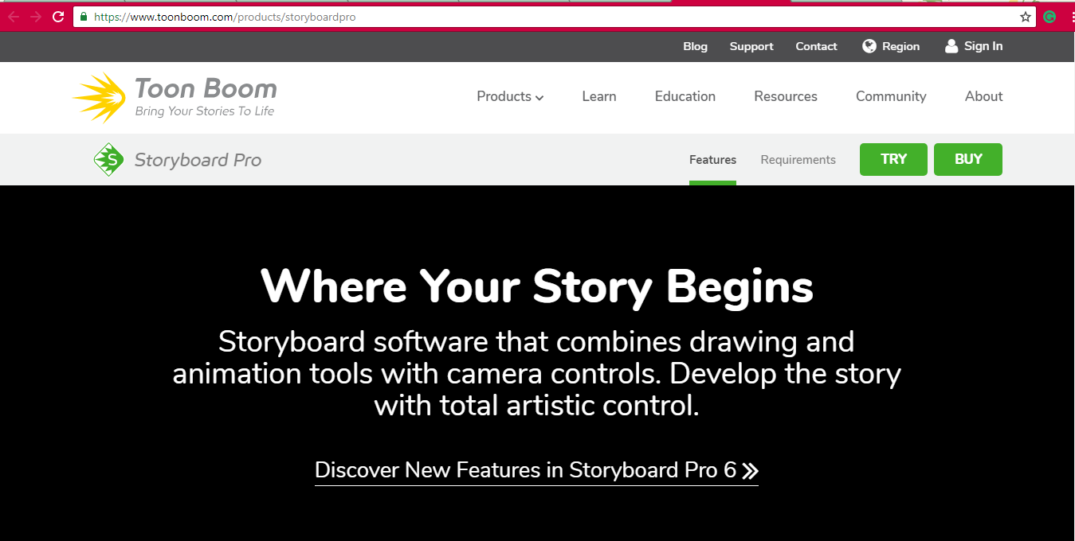

**Section 3: Storyboard That**

Great for Comics, School projects, Blog Content & Infographics.

### Extensive Image Library: Choosing the right images makes a storyboard pop and come together!

* Posable Characters and Scenes from Antiquity to the Space Age
* Customizable Smart Scenes
* Millions of Creative Commons Photos or Upload Your Own

### Flexible Layouts: Every story is unique and choosing the right layout goes a long way.

* Optional Title and Descriptions
* 7 Layout Choices: Classic, T-Chart, Grid, Frayer Model, Spider Map, 16x9 Movie Layout, & Timeline
* Up to 100 Cells per Storyboard

### Intuitive and Simple: Storyboard That was designed to be used by anyone even if you are not a professional artist.

* Drag & Drop Interface
* No Software to Download
* Create Your First Storyboard in Minutes

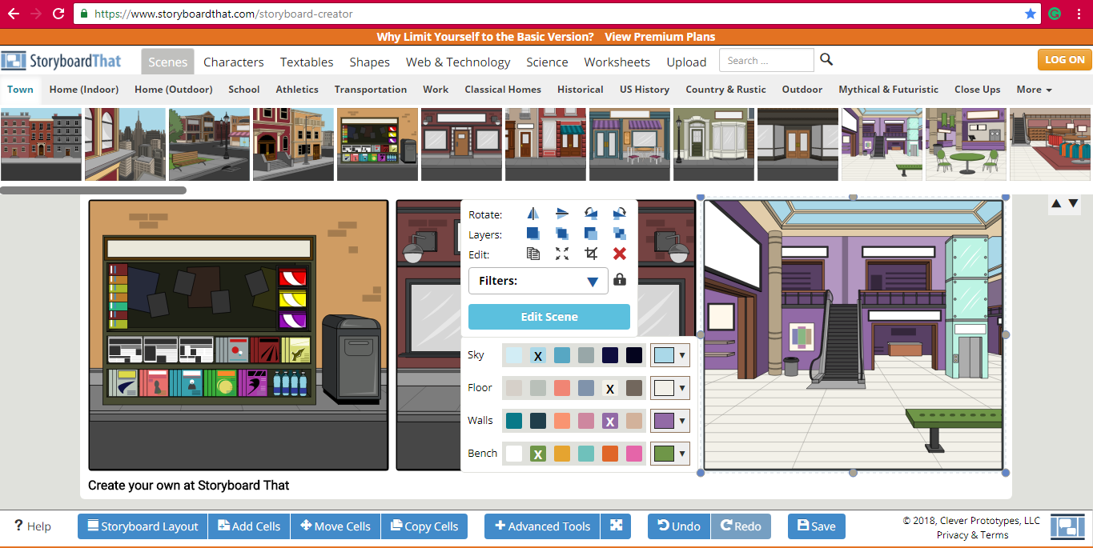

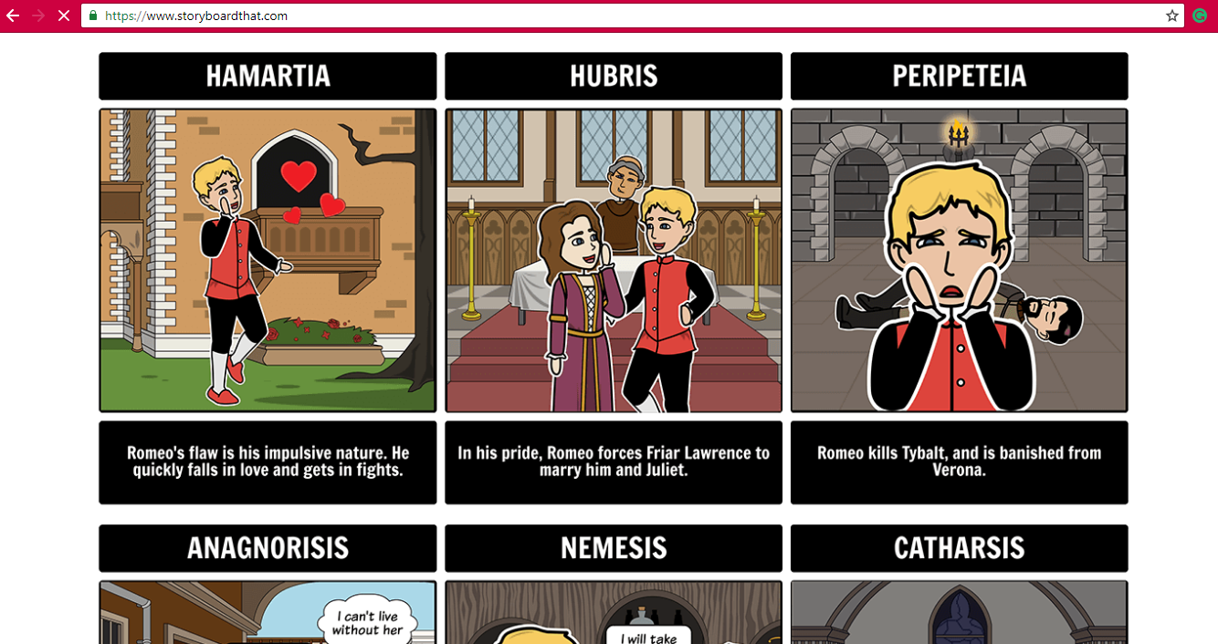

**Section 4: WordsEye**

**Type a Picture!**

Use a simple [position word](https://www.wordseye.com/help/create/layout) (on*, next to, above...*) to make a scene

* *A dog is on the table.*

You can also use [colors](https://www.wordseye.com/help/create/colors), sizes, and distances.

* *A small zebra is 2 feet left of a green tiger.*

Render 3D models only (No Actions or verbs) 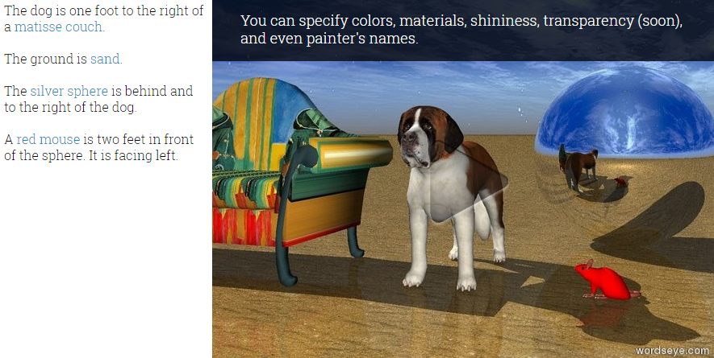

**Section 5: MovieStorm**

 is a real-time 3D animation app published by MovieStorm Ltd.  MovieStormenables the user to create animated movies, using machinima technology. It takes the user from initial concept to finished, distributed movies.

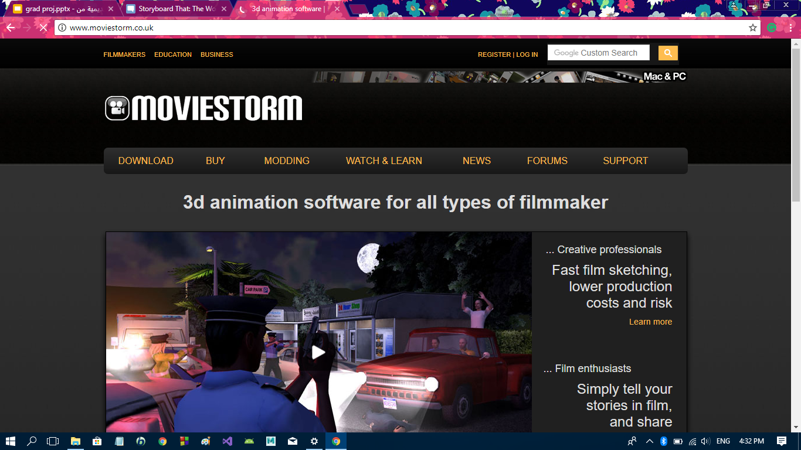

**Section 6: ScriptOmovie**

script to movie is my graduation project with my team we try to build a system that has the ability to create an animation video form story text with a static use case below image from our efforts.

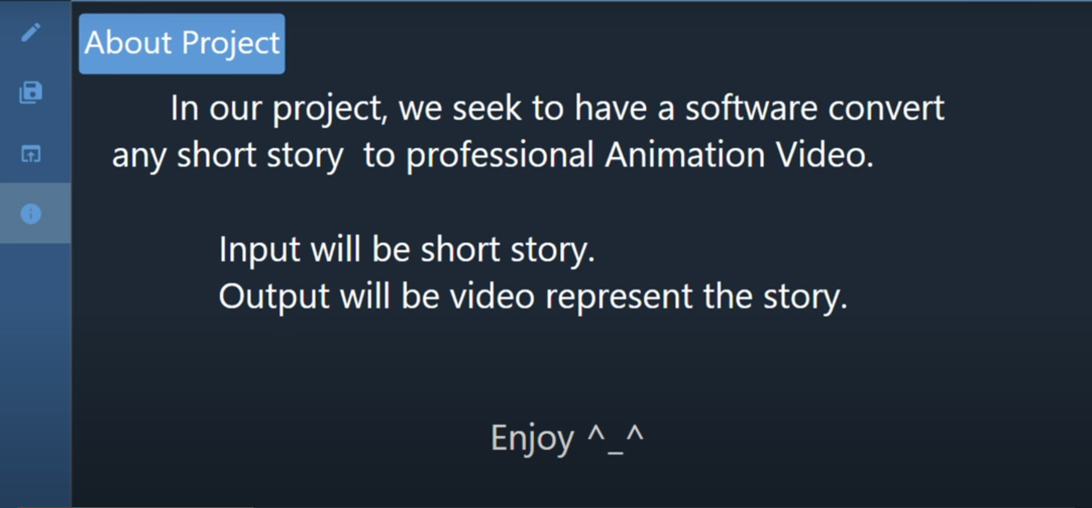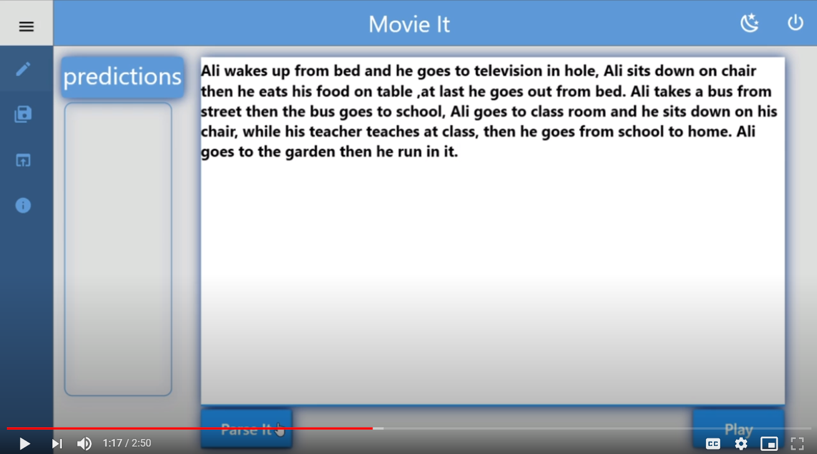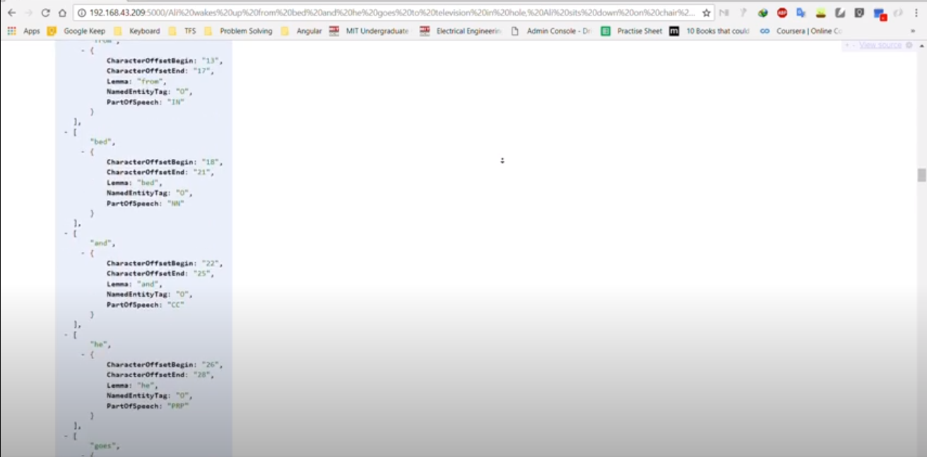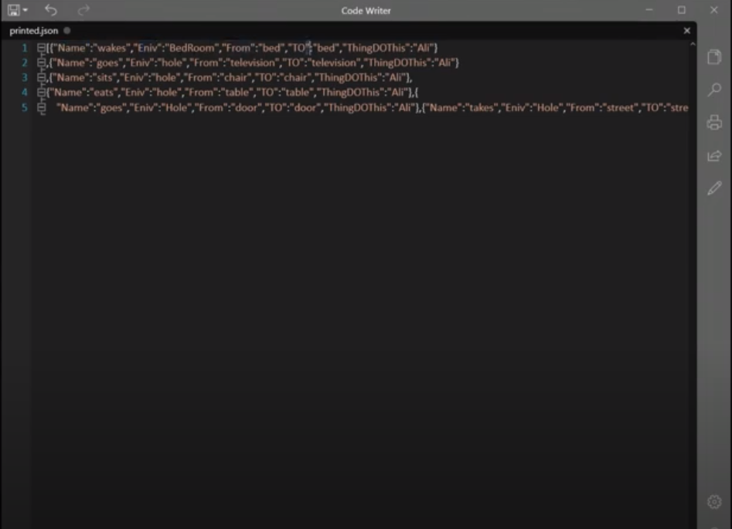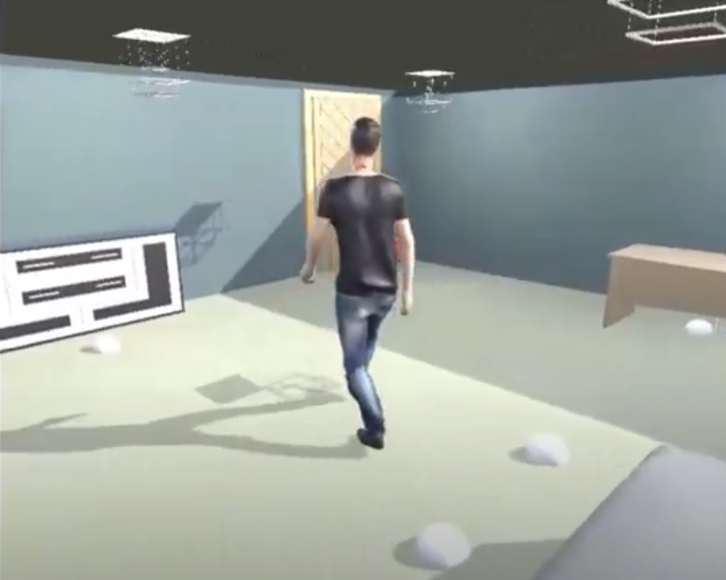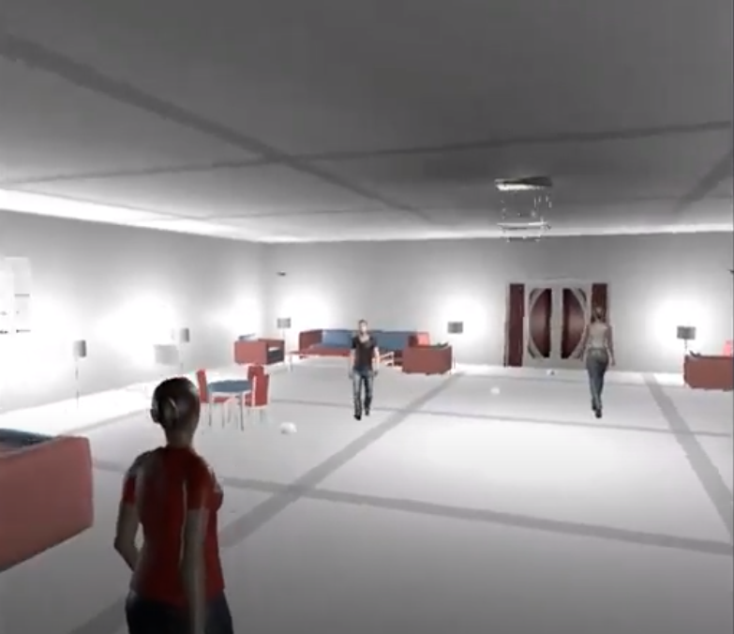

***Chapter 3:***

CONCLUSION AND FUTURE WORK

**This chapter includes:**

1. **Conclusion**
2. **Future work**

**Section 1: Conclusion**

Animation can be put to various creative uses for complementing different segments. It is useful for accomplishing desired objectives in streamlined manner.

So if we make a an intelligent system we able to feed its Perception as an intelligent machine, the knowledge of the story, the scenario of events, the arrangement of events then train the machine using some CV technologies to generate the image of each event as a frame of our animated video, certain number of frames per second lead to an illusion of continuous motion.

**Section 2: Future work**

The next step as to implement the suggested machine learning model that have the ability to understand the script in clearer perception and can collaborate with the text to image translate model.

# *References:*

<https://mapsystemsindia.com/resources/various-uses-of-animation.html>

<https://citeseerx.ist.psu.edu/viewdoc/download?doi=10.1.1.112.5096&rep=rep1&type=pdf>

<https://pdfs.semanticscholar.org/1930/3bb8b07e6b1f921149f5966c245d720f1f5d.pdf>

<https://files.eric.ed.gov/fulltext/EJ1079103.pdf>

<https://essay.utwente.nl/72445/1/Scheurwater_MA_EST.pdf>

<https://link.springer.com/article/10.1007/s10639-019-10025-1?shared-article-renderer>

<https://www.sciencedirect.com/science/article/abs/pii/0010028572900229>

<https://books.google.com.eg/books?hl=en&lr=&id=_ip9T4LONvkC&oi=fnd&pg=PP2&dq=natural+language+understanding&ots=66zp4Dsvff&sig=hNVbdjc1jPgn0SyvMWuArg17AUo&redir_esc=y#v=onepage&q=natural%20language%20understanding&f=false>

<https://arxiv.org/abs/1804.07461>

<https://www.cs.ubc.ca/~amuham01/LING530/papers/radford2018improving.pdf>

<https://arxiv.org/abs/1901.11504>

<https://arxiv.org/abs/1810.04805>

<https://www.aclweb.org/anthology/L16-1376.pdf>

<https://ieeexplore.ieee.org/abstract/document/7953246>

<https://paperswithcode.com/task/text-to-image-generation>

***ملخص الرسالة***

**نظام ذكي لتحويل السيناريو إلى فيلم رسوم متحركة  
  
قررنا محاكاة بعض الأحداث في نصوص إلى بعض مقاطع الفيديو المتحركة لمساعدة الأشخاص على فهم معنى سياق النص .**

**تحويل كل جمله فى النص إلى جمل أكثر وضوحًا وتفصيلاً ، ثم نستخدم هذه الجمل لوصف الصور أو الإطارات المراد بناؤها.**

**الهدف الرئيسي الآن هو استخدام تقنيات الذكاء الاصطناعي لإنشاء نظام ذكي يمكننا تغذية إدراكه كآلة ذكية ، لمعرفة القصة ، وسيناريو الأحداث ، وترتيب الأحداث ، ثم تدريب الآلة باستخدام بعض تقنيات الرؤية بالحاسب على إنشاء صورة لكل حدث كإطار لفيديو الرسوم المتحركة لدينا ، يؤدي عدد معين من الإطارات في الثانية إلى وهم بالحركة المستمرة.**

يقسم المشروع إلى 3 فصول:

* **الفصل الأول** يتضمن مقدمة عن المشروع**.**
* **الفصل الثاني** يشمل الأعمال السابقة**.**
* **الفصل الثالث** يتضمن الخاتمة والعمل المستقبلي**.**



**جامعـــــــة المنصــــــورة**

**كليــــــة الحاسبات والمعلومات**

**قسم علوم الحاسب**

**النص إلى فيلم**

**نظام ذكى لتحويل السيناريو إلى فيلم رسوم متحركة**

مشروع تمهيدى ماجستير  
 علوم الحاسب-كلية الحاسبات والمعلومات  
 جامعة المنصورة

**مقدمه**

**محمد حسام العشرى**

**تحـــت إشــــــــــراف**

**أ.د. /مجدى ذكريا   
أستاذ علوم الحاسب**

**قسم علوم الحاسب**

**كلية الحاسبات والمعلومات**

**جامعة المنصورة**

**د. / ريم الديب**

**قسم علوم الحاسب**

**كلية الحاسبات والمعلومات**

**جامعة المنصورة**

**2019/2020**